**Review Criteria**

Your dashboard will be graded using the following rubric, with point values in brackets.

* [10] Providing a proper URL to the dashboard, and the dashboard appears at that URL without any further user intervention.

<https://public.tableau.com/app/profile/anthony.ravnic/viz/NationalCrimeRatesbyState2019/NationalCrimeRates#1>

* [30] What is one question that the dashboard can answer by utilizing two or more simultaneously displayed charts? What is the answer? How do these two charts indicate the answer? (Spend some time to make sure you have picked a question whose answer is not simply given by just one of the charts, and the combination of the two charts gives a complete answer.)

Q: What does the crime rate look like across the states and which types of crime are most prevalent?

A: based on crime rate per capita (100k citizens) the crime rate is relatively spread out with larger overall crime rates in the southern states. New Mexico also has the highest crime rate despite having a lower population. Property crime is far more prevalent than violent crime (thankfully!) with Larceny-Theft being the majority most of the time.

* [10] Upload a screenshot of your dashboard answering that question by showing two or more simultaneously displayed charts.

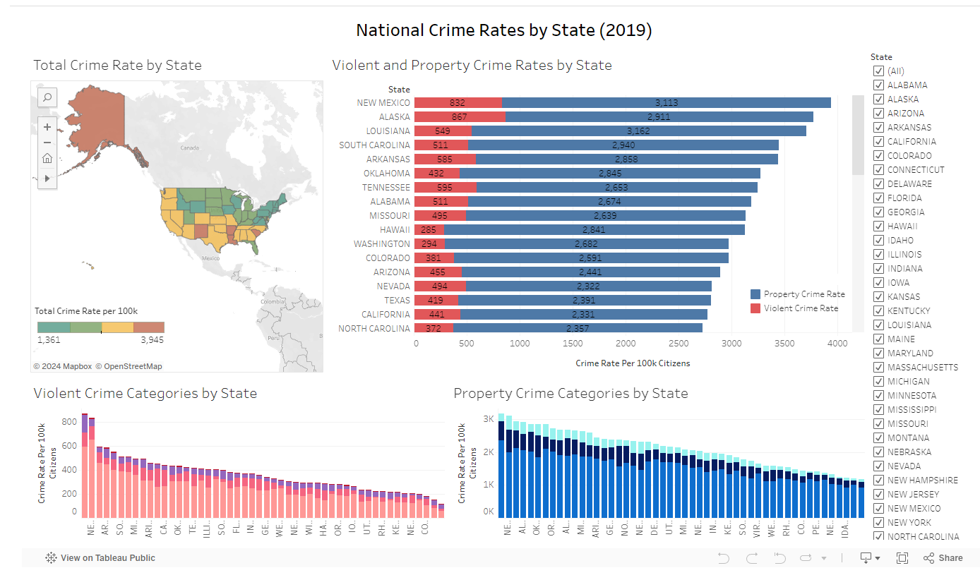

The dashboard is broken into 4 main charts and a right hand side filter (although all are linked filters as well)

* [20] How does the layout of these charts promote visual understanding of the data across multiple charts? Do the charts follow a consistent color scheme and are they well aligned with each other to promote better visual comparisons.

**The dashboard follows an overview first pattern going left to right, top to bottom. It starts in the top left with a broad overview of total crime rates by state displayed on a geographic map (with all states selected). Moving to the right the stacked bar shows the total crime breakout of violent/property crime. Below this chart are violent crime categories and property crime categories broken out into their respective views. The colors are coordinated with a red theme for violent crimes and a blue theme for property crime. The choloropleth map doesn’t follow this theme but shows blue for states with lower total crime rates and red for states with higher total crime rates.**

**Overall I think the layout and themes help the user quickly understand the details. If I had more time and room, I would likely add total volume and the yearly total crime values in.**

* [10] Indicate which chart should be graded as a "first" chart. Then justify the choice of this chart type, its axes and marks based on the data variables it shows.

The “first” chart would definitely be the top left choropleth graph as it gives an overall geographic layout with total crime rates displayed

* [10] Indicate which chart should be graded as a "second" chart. Then justify the choice of this chart type, its axes and marks based on the data variables it shows.

The second chart would be the horizontal stacked bar chart that gives a scrollable list of states with additional violent/property crime statistics along with value labels in the bars

* [10] How does your dashboard provide details on demand?

All 4 charts give detail on demand when the bars are hovered over. Some give more detail than others depending on which graph the user hovers over.

* [10] How does your dashboard support cross-filtering between these two charts? **(Required for 4 credit hour students. Optional extra credit for 3 credit hour students.)**

Cross filtering is achieved in all four graphs by state. The user can select any range of states and these states will be selected and filtered down to in the other charts. If all charts need to be filtered (including the originating one) then the state checkbox filters on the right hand side will allow this

I chose to not include violent/property crime category filters as it would make understanding the choropleth chart difficult and also the bottom violent and property crime breakouts

Additional Notes:

**CS416-Dashboard-Project**

public repository to house CS416 Dashboard data for grading purposes

In this repository you will find:

1. a word doc titled "Dashboard Project Instructions" that asnwers the review criteria questions for the project
2. An Excel file "Table 5" dataset that summarizes crime by state for 2019. This was downloaded from the FBI.gov website found here: <https://ucr.fbi.gov/crime-in-the-u.s/2019/crime-in-the-u.s.-2019/topic-pages/tables/table-5>
   * This data had to be cleaned in order to show totals, in some cases this data was formed using some estimates/extrapolations on population crime rates. These extrapolations were performed by the fbi to get a 100% population estimate for each state.
   * data for each crime category was then used to calculate a crime rate per 100k, in addition a total crime rate was created based on the summation of violent and property crime rates (two mutually independent categories)
3. An Excel file "Table 6" dataset that summarizes crime in the US by year (2000-2019). This was also downloaded from the fbi.gov website found here: <https://ucr.fbi.gov/crime-in-the-u.s/2019/crime-in-the-u.s.-2019/topic-pages/tables/table-1>
   * This data was also cleaned in a similar fashion to 2 above; however, because of the constraints on the dashboard being one page and a timeline chart taking up a lot of room, I ultimately didn't use it in the project (although a sheet does exist for it)
4. A final cleaned dataset "FBI Violent and property crimes by state and year (Union) was used for the project. this is simply a union of the state dataset (2) and year dataset (3). This was done because the crime categories were already very similar and it made it easier to report in tableau. some columns were added (state and year) in this dataset to properly capture some of the differing fields between the two.
   * the yearly data was not used in the project although could be utilized later if need be. it did need to be filtered out in the sheets to make the summations correct

**Additional considerations**

1. the data used was only cleaned to get rates per 100k citizens because raw volume would be biased towards larger populous states
2. The heat map contains a cool to hot coloring, but is a different enough color scale to not be confused by violent crime (red) and property crime (blue)
3. other international crimesets were investigated (UN crime set) but were found to be to varying between the relative definitions and types of crimes to that of the FBI's definition, and so only the FBI state 2019 set was used
4. Cross filtering is the ability to select multiple states in any of the charts and have it filter to those specific states in the other charts
5. the violent crime and property crime visuals initially are somewhat tight (the state name isn't fully visible). however once filtered the names can become visible. This was done to give a 1000ft view of the data with the knowledge that hovering would display the name of any bar that was desired